Forward Problem:
3. Make reasonable guesses of the parameters. Use the parameters to predict Y. Plot Y and the data to make sure the parameters are reasonably close to the true parameters.
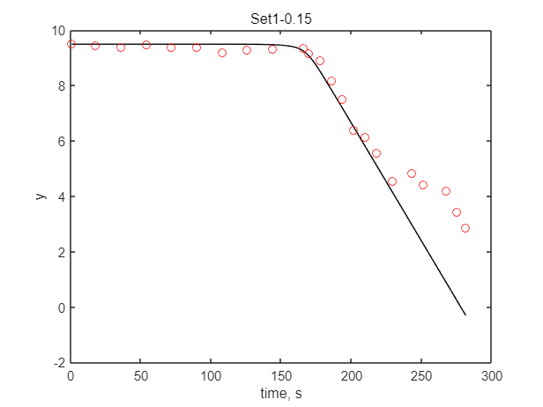
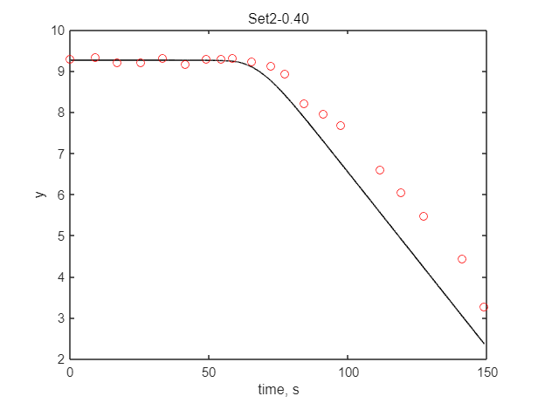
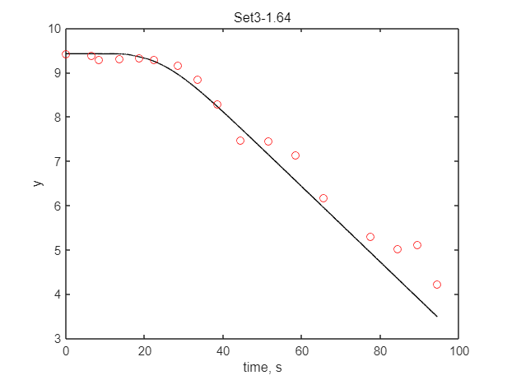
4. Plot the scaled sensitivity coefficients for each parameter and Ypredicted on the same plot.

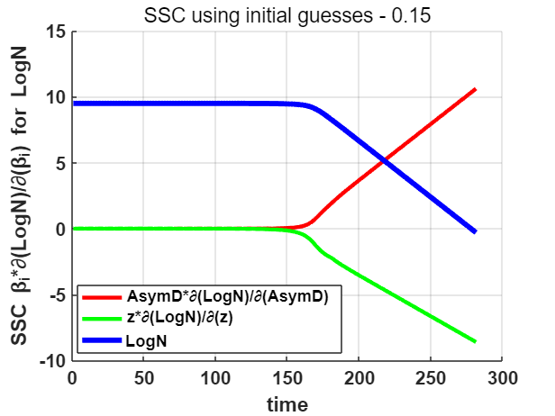
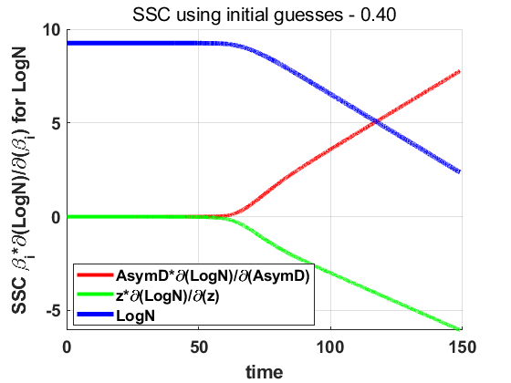

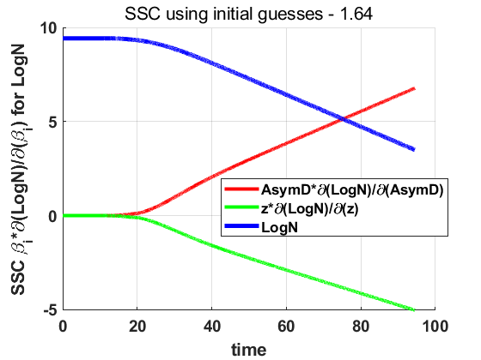

a. Which parameters can be estimated, and why?
Each of the two parameters.
Because none of the X’ was completely linearly dependent, each of the two parameters could be separately estimated.
b. State which parameters will be estimated most accurately, in order.
β1 > β2, because β1’ SSC > β2’ SSC.

Ordinary Least Squares (OLS) Inverse Problem:
6. Estimate parameters using OLS and obtain all statistical results. Report all statistical measures, and interpret the results as to what insights we can gain:
Parameters estimation results:
beta = 1×2 6.3519 3.5544
which means: AsymD=6.3519, z=3.5544.
a. Parameter standard errors, relative errors, confidence intervals, and correlation matrix;
standard errors: sigma = 1.9537 1.2000
relative errors: relerr(%) = 0.3076 0.3379
confidence intervals: will be shown in the following plots.
correlation matrix: R = 1.0000 0.9984
0.9984 1.0000

From relative errors, we can estimate β1 and β2 with relative accuracy, β1 and β2 have high correlation according to the R matrix.
b. Root mean square error of the dependent variable;
rmse = 0.4178
c. Fitted curve and the observed data on the same plot. Show the asymptotic CB and PBs.
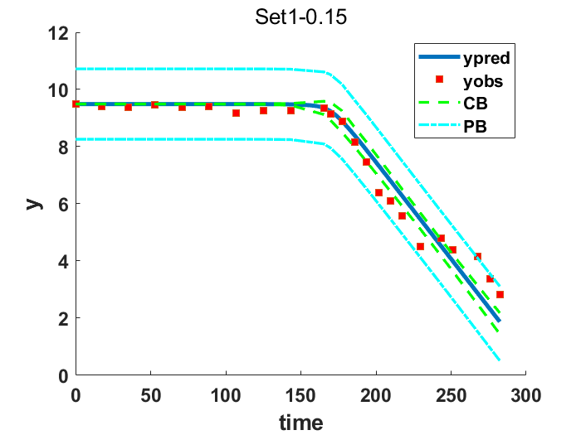

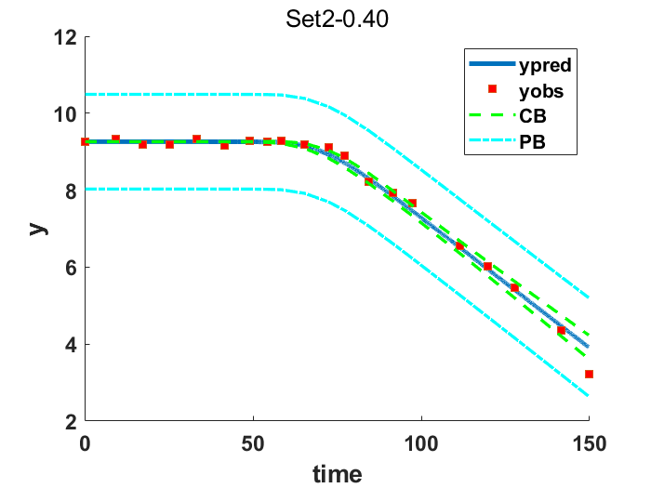
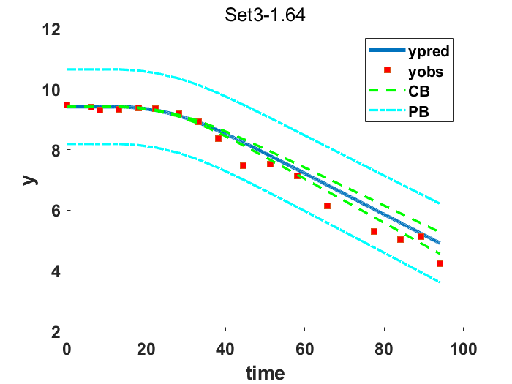

d. Residual scatter plot and residual histogram. List whether the first five standard statistical assumptions were met or not.
01001
Assumption1: 0, when the y is large, the error is small, and when the y gets smaller, the error gets larger.
Assumption2: 1, mean(resids)=-0.0826≈0
Assumption3: 0, constant variance of errors over x is false
Assumption4: 0, with number of runs < (n+1)/2, 4<12, 7<10.5 and 2<9.
Assumption5: 1, normal distribution of errors.
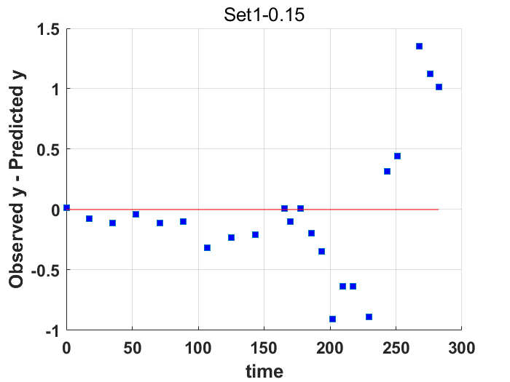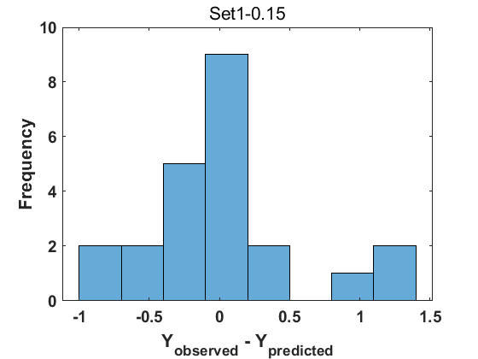

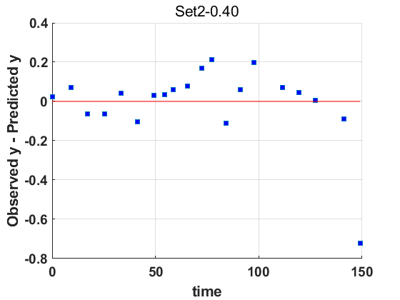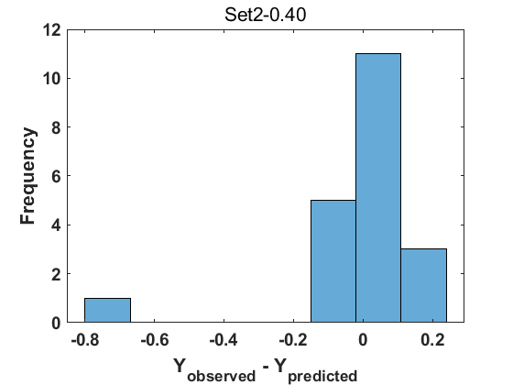

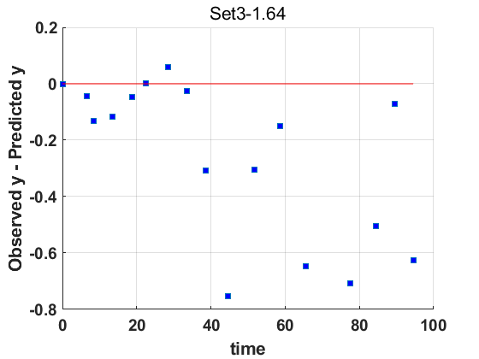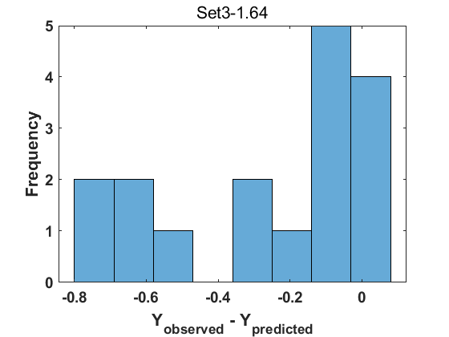
e. Final scaled sensitivity coefficients.
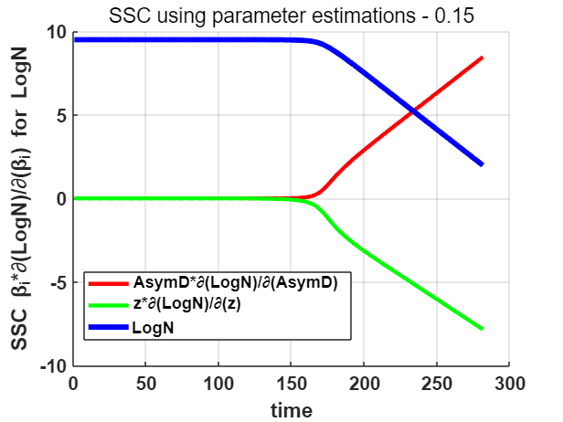
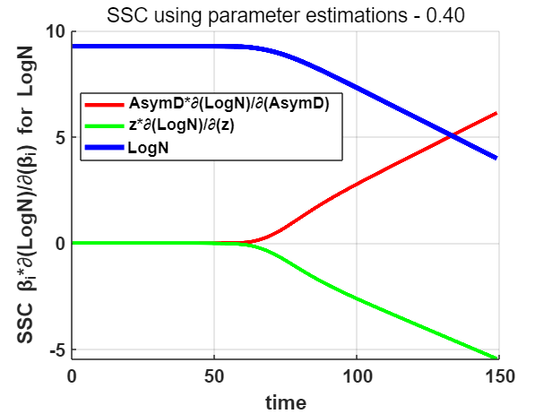
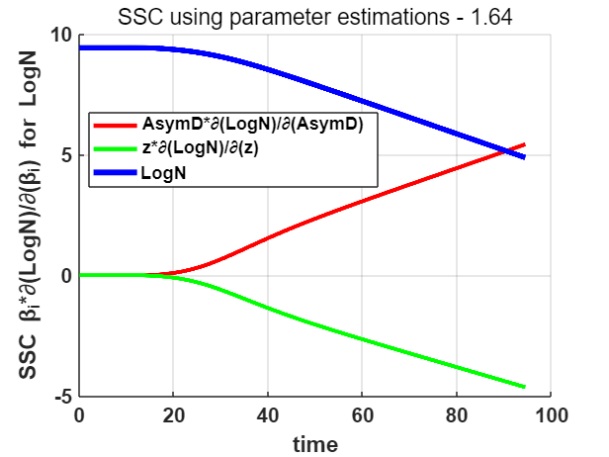

Optimal Experimental Design (Forward Problem):
7. Plot the delta criterion and plot all C11, C22, …Cpp(p = # of parameters) curves, assuming fixed parameter values, to determine an optimal experimental design. If there is no optimum, show how you know that.
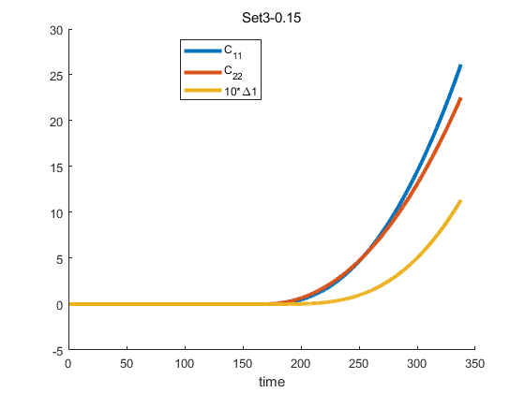
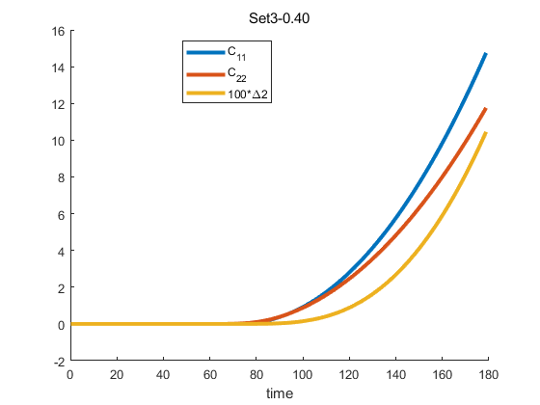
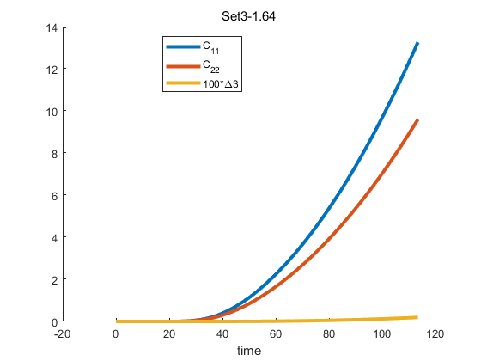
There is no optimum, because the delta keeps going up and does not hit a maximum, it means the longer the experiment runs, the more accurate the parameters will be.
Bootstrapping:
- Using either bootstrapping of data or bootstrapping of residuals, report the 95% confidence interval for each parameter individually, and plot the bootstrap confidence bands (CBs) and prediction bands (PBs). Comment on whether the bootstrap CBs and PBs were larger or smaller than the asymptotic CBs and PBs.
